**EXPERIMENT NO. 3**

**PERFORM AND COMPARE SPATIAL DOMAIN FILTERS**

**EXPERIMENT NO. 3**

**AIM:** To perform Spatial Domain Filtering and compare their performances

1. Smoothening filters

2. Unsharp masking & high boost filtering

**OBJECTIVES:**

1. To apply Smoothening filters of different sizes
2. To perform Sharpening Unsharp masking & high boost filterin**g**
3. To compare their results

**EQUIPMENTS/SOFTWARE:** Python, NumPy, Matplotlib, OpenCV

**THEORY:**

**Spatial filtering:**



**Smoothing filters:**

A smoothing filter is employed to remove high spatial frequency noise from a digital image. The low-pass filters usually employ moving window operator which affects one pixel of the image at a time, changing its value by some function of a local region (window) of pixels. The operator moves over the image to affect all the pixels in the image.

|  |  |  |  |  |  |  |  |  |  |  |  |  |  |  |  |  |  |  |  |  |  |
| --- | --- | --- | --- | --- | --- | --- | --- | --- | --- | --- | --- | --- | --- | --- | --- | --- | --- | --- | --- | --- | --- |
|  | |  |  |  | | --- | --- | --- | | 1 | 1 | 1 | | 1 | 1 | 1 | | 1 | 1 | 1 | |  | |  |  |  | | --- | --- | --- | | 1 | 2 | 1 | | 2 | 4 | 2 | | 1 | 2 | 1 | |
|  |  |  |  |

**Sharpening filters:**

A Sharpeningfilter can be used to make an image appear sharper. These filters emphasize fine details in the image - the opposite of the low-pass filter. High-pass filtering works in the same way as low-pass filtering; it just uses a different convolution kernel.

**Unsharp Masking:**

The unsharp filter is a simple https://homepages.inf.ed.ac.uk/rbf/HIPR2/mote.gifsharpening operator which derives its name from the fact that it https://homepages.inf.ed.ac.uk/rbf/HIPR2/mote.gifenhances edges (and other high frequency components in an image) via a procedure which subtracts an unsharp, or smoothed, version of an image from the original image. The unsharp filtering technique is commonly used in the photographic and printing industries for crispening edges.

Procedure:

1. Import libraries: NumPy, OpenCV, Matplotlib
2. Read Image
3. Define the mask.
4. Perform convolution on the image with the mask for averaging and High Boost Filtering
5. For Unsharp Masking-
   1. Unsharp Mask= Original image – blurred image
   2. Output image= Original image + A* Unsharp Mask

**Code & Output:**

import numpy as np  
from matplotlib import pyplot as plt  
from matplotlib import gridspec  
import cv2  
  
img = cv2.imread("C:\\Users\\admin\\Downloads\\lenna.png")  
img = cv2.cvtColor(img, cv2.COLOR_BGR2GRAY)  
plt.subplot(2,2,1)  
plt.title("Input Image")  
plt.imshow(img,cmap=plt.cm.gray)  
  
"""******LPF***************"""  
# Obtain number of rows and columnsof the image  
m, n = img.shape  
mask = np.ones([3, 3], dtype = int)  
mask = mask / 9  
img_new = np.zeros([m, n])  
  
for i in range(1, m-1):  
 for j in range(1, n-1):  
 img_new[i,j] = img[i-1, j-1]*mask[0, 0]+img[i-1, j]*mask[0, 1]+img[i-1, j + 1]*mask[0, 2]+img[i, j-1]*mask[1, 0]+ img[i, j]*mask[1, 1]+img[i, j + 1]*mask[2,0]  
  
img_new = img_new.astype(np.uint8)  
plt.subplot(2,2,2)  
plt.imshow(img_new,cmap=plt.cm.gray)  
plt.title("LPF Image")  
  
"""**************HPF***********************************"""  
sharp_kernel = np.array([[-1, -1, -1], [-1, 8, -1], [-1, -1, -1]])  
"""cv2.fliter2D() is the function used   
src is the source of image(here, img)  
ddepth is destination depth. -1 will mean output image will have same depth as input image  
kernel is used for specifying the kernel operation (here, sharp_kernel)"""  
  
sharp_img = cv2.filter2D(src=img, ddepth=-1, kernel=sharp_kernel)  
# Showing the sharpened image using matplotlib library function plt.imshow()  
plt.subplot(2,2,3)  
plt.title("Input Image")  
plt.imshow(img,cmap=plt.cm.gray)  
  
plt.subplot(2,2,4)  
plt.imshow(sharp_img,cmap=plt.cm.gray)  
plt.title("HPF Image")  
plt.tight_layout()  
plt.show()

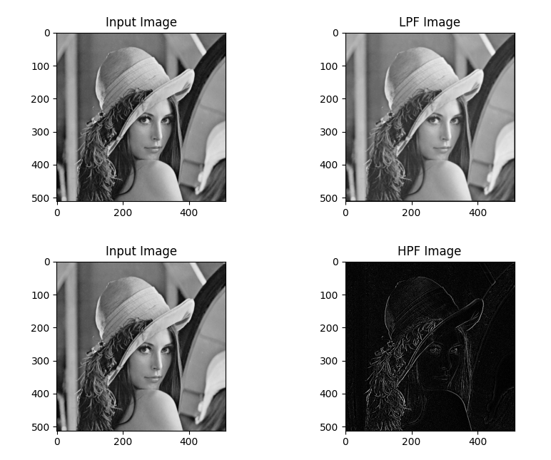

**Conclusion:**

**The experiment was performed successfully. The Smoothening filters(LPF) smooths our image or blur our image. Unsharp masking & high boost filtering detects edges of our images**